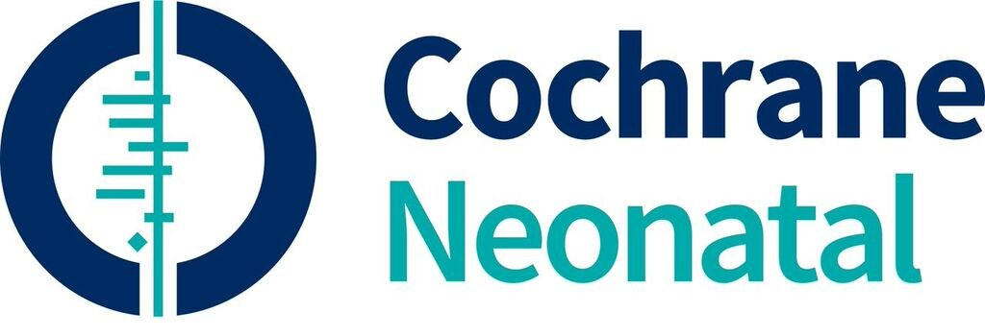

NURSING CONTACT HOURS (1 Credit)

Cochrane Neonatal
Vermont Oxford Network
33 Kilburn Street, Burlington, VT 05401

PARTICIPANT: PLEASE FILL IN YOUR NAME (and retain for your records)
Evidence in Practice: Feeding Strategies and Methods

PLACE: Webcast
DATE OF ACTIVITY: January 24, 2022
ORGANIZATION: Cochrane Neonatal / Vermont Oxford Network
MAXIMUM CREDITS AVAILABLE: 1 Nursing Contact Hour
ACTUAL NUMBER OF CREDITS EARNED: 1 Nursing Contact Hour

In support of improving patient care, this activity has been planned and implemented by The Robert Larner College of Medicine at The University of Vermont and Cochrane Neonatal. The University of Vermont is jointly accredited by the Accreditation Council for Continuing Medical Education (ACCME), the Accreditation Council for Pharmacy Education (ACPE), and the American Nurses Credentialing Center (ANCC), to provide continuing education for the healthcare team.
The University of Vermont designates this live activity for a maximum of 1 AMA PRA Category 1 Credit(s)™. Physicians should claim only the credit commensurate with the extent of their participation in the activity.

